

HARKINS ELEMENTARY School
december 2010

CHRISTMAS CONCERT
Our Christmas concert is scheduled for Wednesday, December 15th^{th} at 9:30 a.m. We will be having ONE concert this year for all grades. Arrive early and enjoy a slide show highlighting activities from first term. Thursday, December 16th will be our storm date. Come and experience the musical voices of the students of Harkins; everyone is welcome!!

CHRISTMAS DINNER
Christmas dinner will be served in the cafeteria on Friday, December 10th. The cost of the turkey dinner, with potatoes, mixed vegetables, gravy and dressing, milk, and ice cream for dessert, is $5.25.

BEFORE YOU CALL THE SCHOOL
Before you call the school, please check our website, as you may find the information you are looking for there (i.e. skating schedule, basketball schedules, Christmas concert date).
We do not have a full time secretary, or she may be away from her desk. You may leave a message and be waiting for a call back, only to find out that the answer to your question was on the website. ☺
Visit our website regularly, as it is updated every day:
http://harkinselementary@nbed.nb.ca


CLASS PICTURES
Class pictures are available for $2.00 each. If you wish to purchase one, please send the money in to your child’s homeroom teacher.

Book Fair
We are pleased to announce that the recent Scholastic Book Fair realized a commission credit of $803.83 (to be spent through Scholastic) as well as a varied selection of new books for the library purchased directly from the fair. We have once again reached our goal of 60% profit - $6.00 gained out of every $10.00 spent at the Fair! Thank you to all who supported this worthwhile fundraiser. A special thank you to parent Cynthia Doak for volunteering so much of her time!

The Project of Champions

By: Benson and Katherine
In 4D we are doing a class project to raise money for some local charities. This month our class chose the S.P.C.A. to donate to. So far we have done things like Hat Day, recycling, and a bake sale for the whole school. The bake sale included many things like cookies, cakes, fudge, and cupcakes.

Class Project-Mrs. Donovan
Students are earning credits in class through achievement, good behaviour and attendance. They can use their credits to buy things like homework passes, pencils, erasers, computer time, or book vouchers. But, they are required to donate a percentage of their credits to charity. These credits get transferred into money through their fundraising efforts. Keep up the great work!

COLD WEATHER
Now that the weather is getting colder, we would ask that students are dressed warmly (hats, mittens, scarves, boots, ski pants, etc.). It is a good idea to pack extra socks, mittens and pants in your child's book bag in case they get wet while outside. It is also a good idea to put your child’s name on all articles of clothing in case they go missing.

CHRISTMAS BREAK
The last day of school for students is Thursday, December 23rd, which is a full day. In the event that it is a half day, we will be using the Early Dismissal/Storm Closure run. Please note, students return to school on Tuesday, January 11th, 2011.


HOME & SCHOOL NEWS
- The next Home & School meeting is on Tuesday, December 7th at 6:00.
- We are selling Subway peeler cards for $10.00; these are buy one, get one free peelers. Please send your money to the school if interested in this great deal.
- Pictures with Mr. & Mrs. Claus will be on Monday, December 6th. If you wish your child to have his/her picture taken, please send $2.00 to school on Dec. 6th.
- Popcorn is on sale every Wednesday for 50 cents per bag (pre-order/pay on Tuesday).

Pedometer Challenge

The Harkins Elementary Pedometer Challenge has now wrapped up for grades 2-5. Mr. Flynn would like to congratulate all of the students who participated, as it certainly kept them moving through the damp month of November. The champion class will be calculated based on the highest average number of steps taken. The winning class- to be announced the first week in December- will receive a surprise party! Well done, students!

M.O.V.E.
(Miramichi Outdoor Venture Experience)

On December 7th, Mr. McKinnon from M.O.V.E. (Miramichi Outdoor Venture Experience) will be visiting Harkins Grade 5 students to teach them about canoeing. On December 10th, Mr. Sonier's Grade 5 class will be going to the MVHS pool to put into action what they learned from Mr. McKinnon. A notice will be sent home in the next week with more information about these two days.

SKATING SCHEDULE
SKATING DATE | Bus Leaves for Rink | Time on Ice | Return to School | CLASS
Thursday, December 2nd | 8:45 | 9:00 9:50 | 10:00 | 3-Hennessy
 |  |  |  | 4-Donovan
 |  |  |  | 5-Sonier
Thursday, December 2nd | 10:10 | 10:20 11:10 | 11:15 | K-Butler
 |  |  |  | K-Collette
 |  |  |  | 1-Newman
Thursday, December 16th | 8:45 | 9:00 9:30 | 9:40 | 1-LaBerge
 |  |  |  | 2-Barrieau
 |  |  |  | 2-Trevors
Thursday,  December 16th | 9:30 | 9:40 10:30 | 10:40 | 3-Hennessy
 |  |  |  | 4-Donovan
 |  |  |  | 5-Sonier
Thursday, December 23rd | 8:45 | 9:00 9:50 | 10:00 | K-Butler
 |  |  |  | K-Collette
 |  |  |  | 1-Newman
Thursday, December 23rd | 10:10 | 10:20 11:10 | 11:15 | 1-LaBerge
 |  |  |  | 2-Barrieau
 |  |  |  | 2-Trevors
Thursday,  January 20th | 8:45 | 9:00 9:50 | 10:00 | 3-Hennessy
 |  |  |  | 4-Donovan
 |  |  |  | 5-Sonier
Thursday,  January 20th | 10:10 | 10:20 11:10 | 11:15 | K-Butler
 |  |  |  | K- Collette
 |  |  |  | 1-Newman


HARKINS BASKETBALL

Mr. Flynn and Mrs. Newman are very excited to get the Harkins basketball season underway. Mr. Flynn will be coaching the boys’ team, which plays its games on Mondays and practices on Wednesdays. Mrs. Newman’s girls’ team plays their games on Tuesdays and practices on Thursdays. Schedules have been sent home and are also available on the school website. This year, both teams have been opened to students in grade 3 as well as those in 4 and 5. We look forward to having a great season!
All basketball games are to begin between 3:30 and 4:00 on school days with the exception of games that are played in Blackville which will begin at 4:30.


Gym Class:

Reminder to all parents that students must have a pair of indoor sneakers for the winter months, as winter boots are not permitted in the gymnasium.

Important Dates:
December 6 – Pictures with Mr. and Mrs. Claus
December 10th – Christmas dinner (cafeteria)
December 15th – Christmas concert (9:30)
December 23rd – Last day of school
January 10th – Curriculum Implementation Day for teachers; no school for students
January 11th – First day back to school


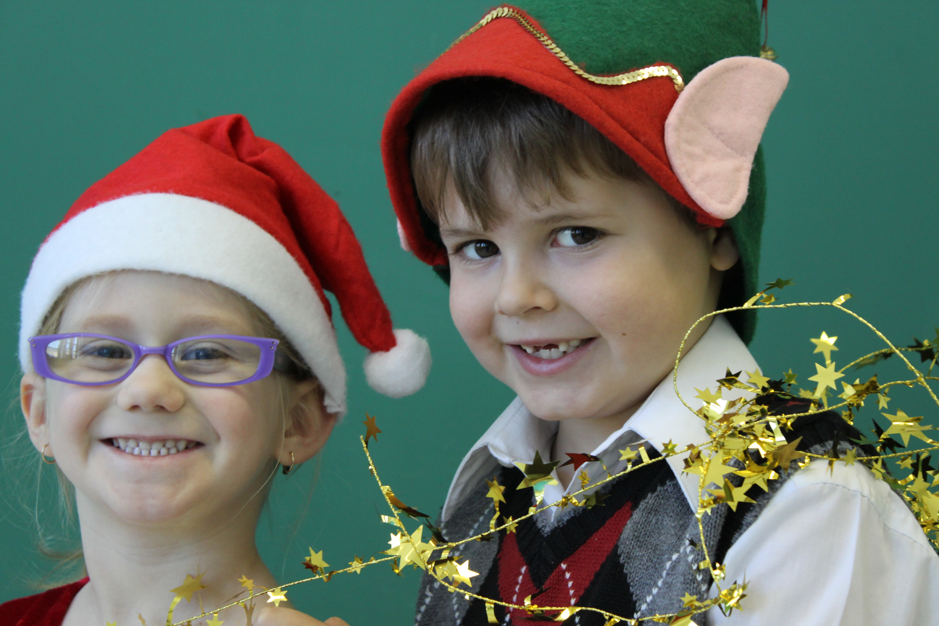

We would like to wish all the families of Harkins Elementary…
A very Merry Christmas and a Happy New Year!

