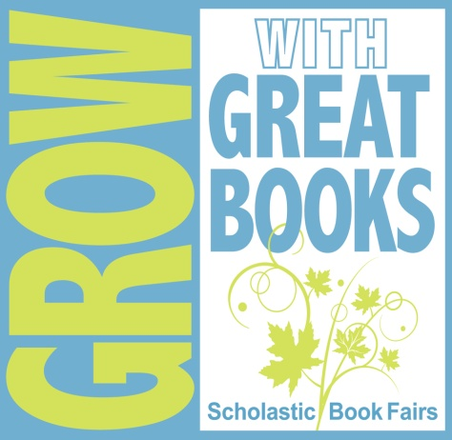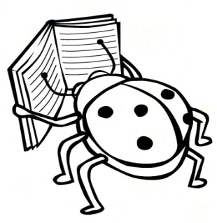

LIBRARY NOTICE!
Harkins is having a Scholastic Spring Bookfair!
WHEN: Thursday evening, March 31 – [3:30 – 6:30 pm]
Friday, April 1 - [9:00 – 3:00 pm]
Monday, April 4 – [9:00 – 4:00 pm]

WHERE: HARKINS ELEMENTARY SCHOOL LIBRARY
Please visit the FAIR to see all
the exciting new titles -
SPRING, EASTER, SUMMER reads will be available!
Just a reminder that ‘all sales’ benefit the School hosting the Fair and places new books directly back into the hands of the students. Recently, Harkins Library has added a variety of new, colourful titles to its current collection, as a result of its Scholastic Bookfairs.
Interested in volunteering a few hours of your time on Monday? Please call and speak with the Library Assistant.

