

HARKINS ELEMENTARY
NEWSLETTER – APRIL 2010

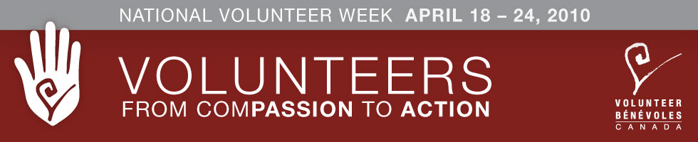
We would like to take this opportunity to thank the many volunteers who lend a helping hand at our school. Your efforts do not go unnoticed. We would like to invite all the volunteers to the Student Assembly on April 23 at 12:30 for a special acknowledgement of your time and efforts. Also at this time students will be performing their musical selections from the Music Festival and the Turnaround Achievement winner will be announced.

This award is given annually to a deserving student who has made a significant improvement in academics despite life circumstances. This year’s recipient will be announced at the student assembly on April 23 at 12:30.
Turnaround Achievement Award


SCIENCE EAST
April 12th-April 23rd
A Science East display will be set up for two weeks so students can participate in science experiments.

TNB
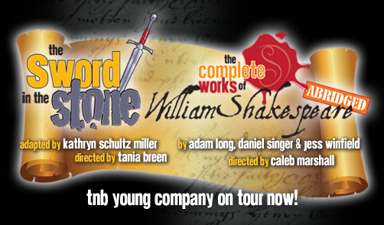

The students of Harkins will see a TNB production on April 7th at 9:00 a.m. The play is The Sword in the Stone. There will be no charge to students as the school will be covering the cost.

Harkins’ Birthday Celebration

Harkins will celebrate its 115th Birthday on

May 27 & 28

Plans are underway for the big event. On Thursday, May 27th there will be an old-fashioned carnival for the students and the community. On Friday, May 28 the students and public will see a drama performance written by Cathy Carnahan especially for the event. More details will follow. There is a meeting on Wednesday, April 14th at 6:30 for all those who would like to help in planning this great event.

GOODY CART:
Goody cart items will be on sale beginning Monday, April 12th. Items will be sold on Monday and Fridays ONLY. All money raised will go towards the 115th Birthday Celebration. More information (list of items and prices) will follow.

SILENT AUCTION:
We will be holding a silent auction during parent/teacher on Thursday, April 8th and Friday April 9th. If you have any items you would like to donate please send them into the school.
All proceeds for the goody cart and silent auction will go towards the birthday party

Harkins Elementary
Science Fair Winners
We held our science fair onTuesday, March 16th; the following are the winners who went on to the District Fair on Thursday, March 18 at Gretna Green:
- Ethan Johnston
- Abby Larsen/Shelby Morris
- Kieran Lukiv
- Alana Dowling /Carlee Mitchell
- Jordan Lobb-Carter/Bailey MacCallum
- Julien Williston
Congratulations to all participants on ajob well done !!


Students are working very hard with the musical "The Magical Land of Oz.” They have been putting in many hours after school and on Saturdays. They are doing a wonderful job! A date has yet to be determined for the performance, but we are presently looking at the end of May.

District Music Festival
Students are also busy preparing for the district music festival which will take place Tuesday, April 13 & Wednesday, April 14.

Math-a-Thon
(Formerly the Spell-a-thon)


It was decided that the Math-a-Thon will replace the Spell-a-thon this year. It will not be a fundraiser this year but merely a competition to improve the math skills of students.

Prizes will be awarded in each class, and winners will advance to the gym for the finals on May 21st.

The District Spelling Bee will be on
May 8th.


FLOOR HOCKEY
Harkins will be once again participating in the District-wide elementary floor hockey league. This team will be open to grade five and possibly grade four students, depending on the number of grade five students who wish to play. To participate students, need a certified hockey helmet with cage, hockey gloves and a stick that has no tape. More information will become available once a schedule and team is made.

Mr. Flynn


DRESS FOR THE WEATHER
The playground area is very wet and muddy; please make sure your child is dressed for this weather.
Extra socks and pants are a good idea to have in students’ bookbags in case they need a change of clothes.

Home & School News
- We are looking for new members for the executive next year. If you are interested, please call Tracy Johnston.
- Pizza coupons are on sale for $20.00 each. Please send in the form that was sent home with your child and the money if you wish to purchase a coupon (includes pizza and garlic fingers). We are hoping to have the coupons on sale during parent- teacher.

- Popcorn will continue to be sold this month. Remember to pre-order on Tuesday for Wednesday.

DATES TO REMEMBER

April 2 – Good Friday – No School
April 5 – Easter Monday – No School
April 7 – Report Cards go home
TNB 9:00 am
PSSC meeting 6:30
April 8th - Evening – Parent Teacher
April 9th – Morning – Parent Teacher
April 12th – Science East Display
April 14th – Meeting for Harkins’ Birthday 6:30
April 23rd –Assembly to honour our Volunteers
April 29th School Heritage Fair
May 6th – NBTA – No School for students
May 7th–Subject Council
No School for students
June 25 – Last Day of School for Students

