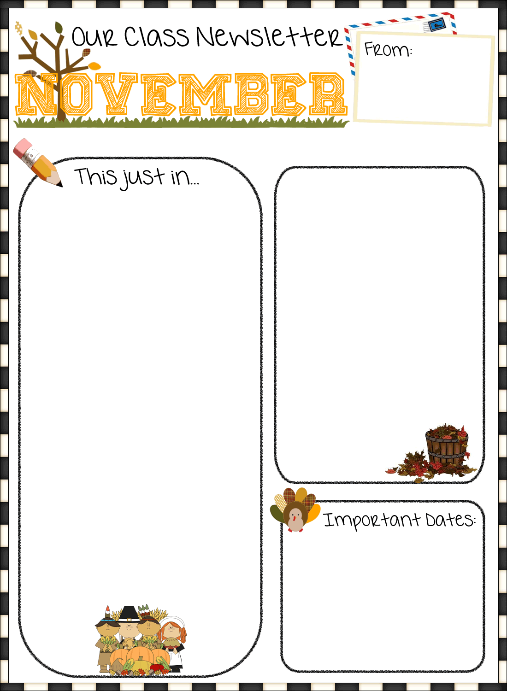

Harkins Elementary  
Mrs. Mountain-Collette and Mrs. Dickson  
Kindergarten

**Report cards go home:**

* Nov. 19th (Please return envelopes)

**Parent Teacher:**

* Nov. 21st (4pm -6pm)
* Nov. 22nd (9am – 12pm)

**Literacy**

Students are continuing to learn the letters of the alphabet through the use of Zoophonics. This month the letters we will be focusing on letters, sight words and reading beginner level books. We will be learning how to use our sight words in sentences. Students will be learning about word families through rhyme and song. They will be practicing their printing using primarily the ABCBoom! Program.

**Math**

This month, we will be continuing our unit on patterning and sorting. In addition, students are learning number recognition, number formation and counting. We will be learning these mathematical skills primarily through the use of games.

Please remember to read with your child and go over their sight words daily. And please send back sight word cards and books daily, as most days I will be going over them with your child. Also, please ensure that they do not get lost or damaged because it takes a lot of time, effort and money for me to replace them.

I will be sending home beginner level books for your child to practice. They should be able to read some of the sight words on their own and be able to figure out the rest of the sentence by reading the picture and looking at the initial letter of unknown words. Please read it to them first and then have them read it to you. As they read please have them point to each word as they read it. It is also a good idea to ask them questions about the stories they read to you and the ones you read to them.