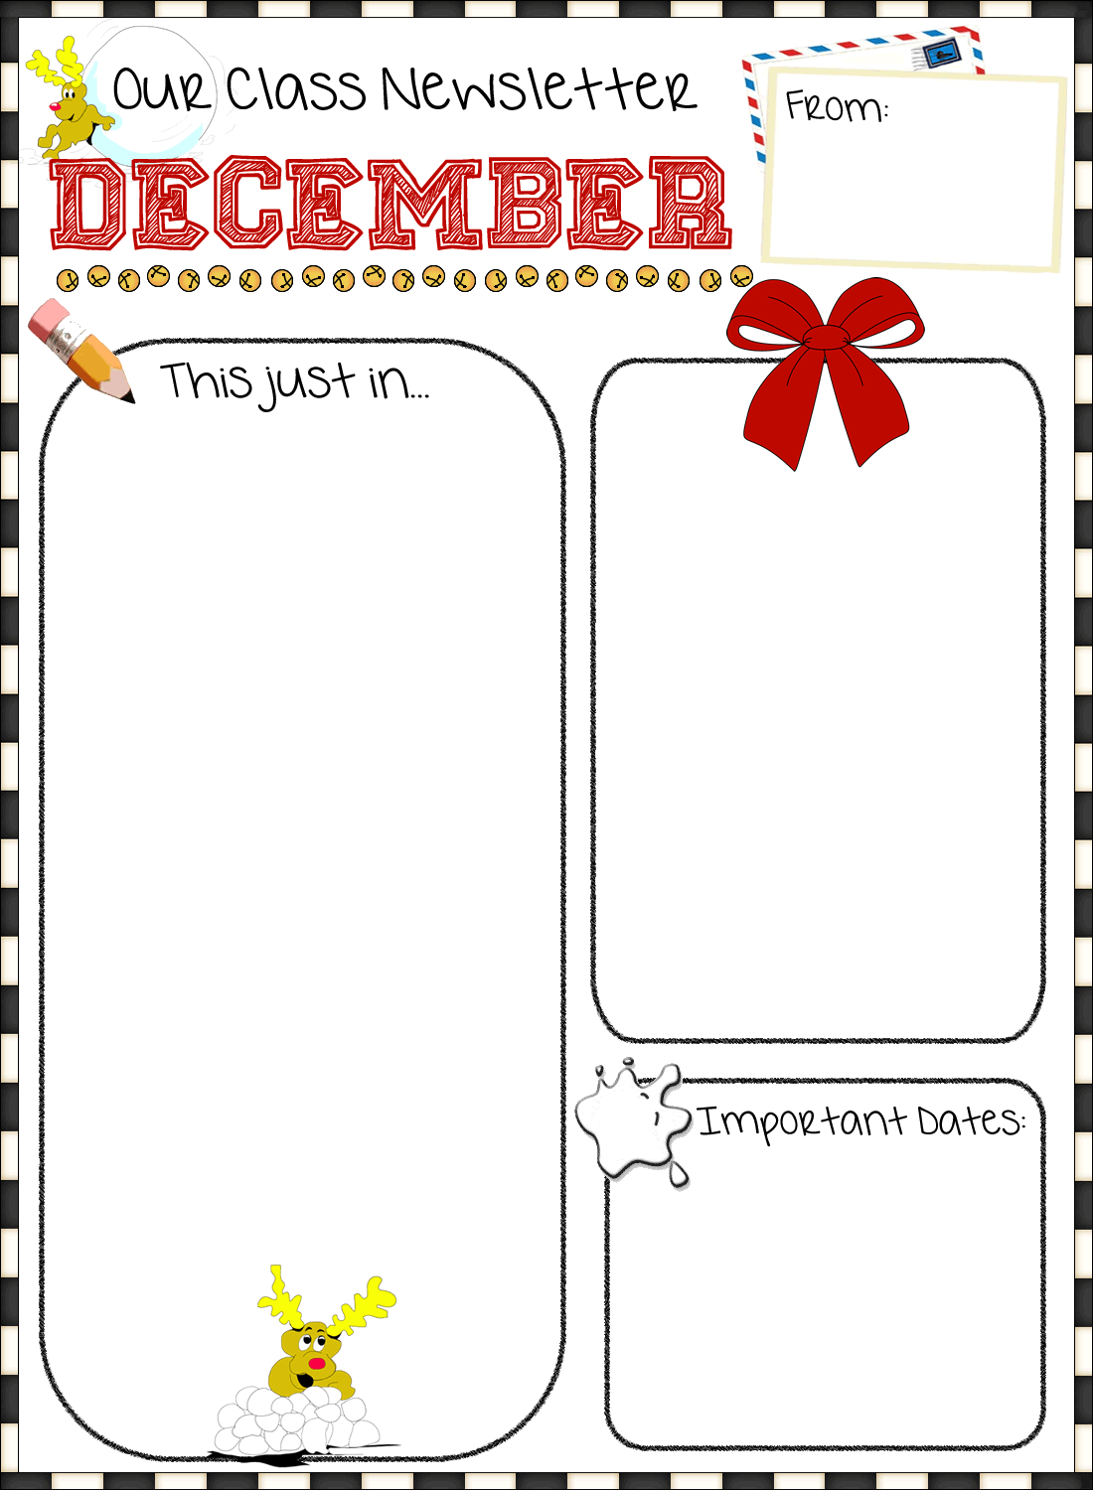

Dec. 11th – Christmas Dinner

Dec. 11th (6-7pm) – Christmas with Mr. and Mrs. Claus

Dec. 13th – PJ Day

Dec. 18th – Christmas Concert

**Merry Christmas**

We want to take this time to wish all of you a very joy filled Christmas and a happy, healthy and prosperous New Year. Let the spirit of love gently fill your hearts and homes. In this loveliest of seasons, may you find many reasons for happiness, especially when you are blessed with these wonderful and special boys and girls that we are so blessed to spend each and every day with. Happy Holidays!!!

Season’s Greetings EVERYONE!! Enjoy!

Students are continuing to learn the letters of the alphabet through the use of Zoo Phonics. Students will review the letters learned thus far as well as continue to learn the characters, signals and sounds for more letters of the alphabet. Students are beginning to read beginner level books on their own. They will continue to learn new sight words and learn to build sentences. Students will also be continuing to learn words through rhyming and using word families. Students will continue to work on writing during a daily Writers Workshop in which they see themselves as authors and their lives as stories to write about. Students will also be adding short sentences to their stories. Please read to your child and have your child read to you daily.

This month in math, we will be continuing the Exploring Numbers units with a review of the unit on patterning and sorting. In these units, students will be exploring the numbers from 1 to 10. The concepts they will be learning are using one to one correspondence, more, less or the same. They will count to find out how many, match a numeral to a quantity, represent a number as 2 parts, name the number of objects in each part, compare 2 sets by one-to-one correspondence, recognize a quantity (to 5) at a glance, count forward and backward from 1 to 5.