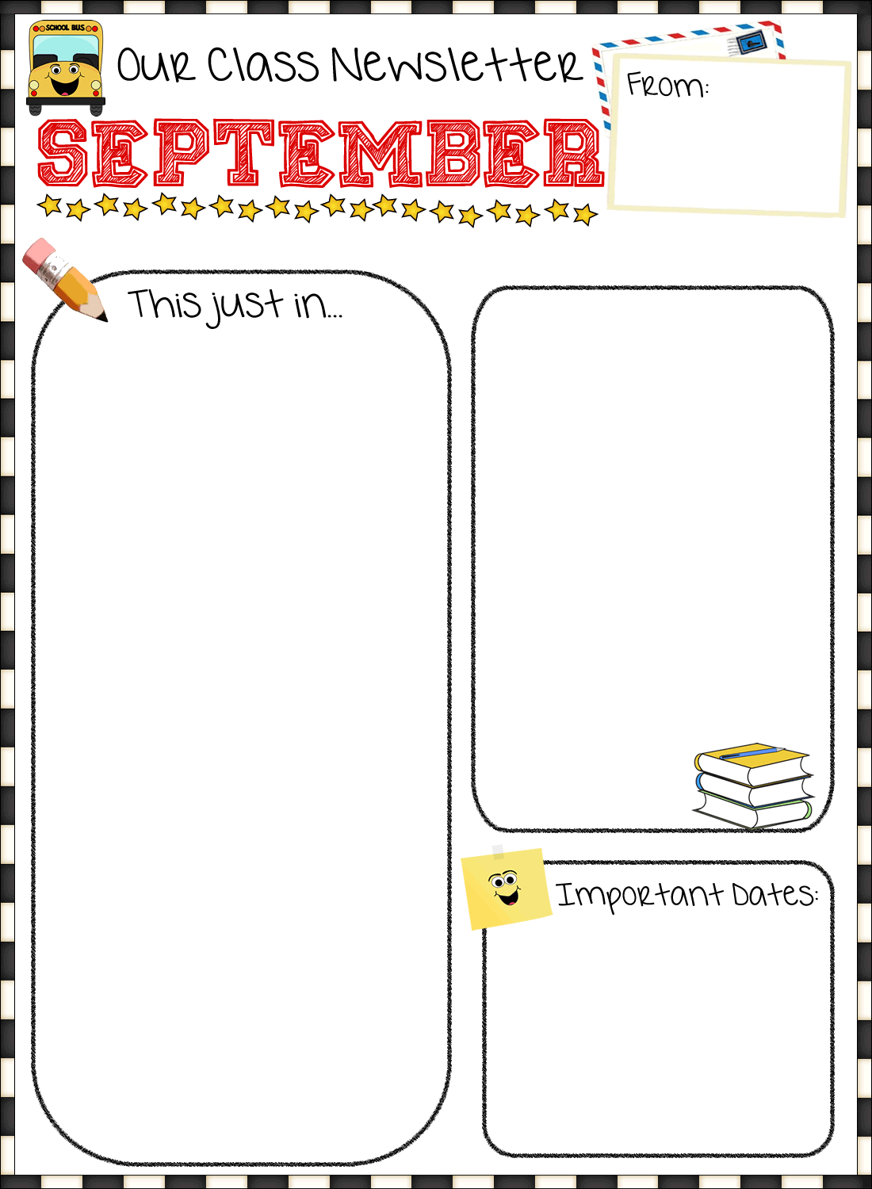

**Harkins Elementary  
KMC and KL**

**Sept 17 – Meet the Teacher**

**Sept 23 – Pictures**

**Sept 25 – Terry Fox Run**

**Happy Birthday to Josie and London**

**Reminders…**

* **Make sure to write a note in your child’s agenda if s/he is going to a different stop in the PM.**
* **Please read to your child daily and have them “read the pictures” of books to you. We will be calling this “Read to Someone” at school.**
* **Homework will be due the last day of the week.**

**Thank you,**

**Mrs. Mountain-Collette and Ms. Lawlor**

**The year is off to a great start!**

**The students are beginning to learn the letters of the alphabet through the use of Zoophonics. This month we will learn about the Zoophonics characters, signals and sounds for the beginning letters of the alphabet. Students will enjoy learning about word families through rhyme and song. The ABCBoom! Program will be used in printing to help the students learn the proper form and direction for printing letters and numbers.**

**This month, we will be beginning our unit on patterning and sorting. In addition, students are learning number recognition, number formation and counting. We will be learning these mathematical skills primarily through the use of games.**