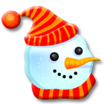 | J a n u a r y  20 - 24
Monday | - Read  - Print a row of q's and draw a picture of something beginning with "q"  - Study sight words
Tuesday | - Read [guided reading book and sentence strips]  - Print another row of "q's"  - Study sight words
Wednesday | - Read  - Math sheet and print a row of "r's"  - Study sight words
Thursday | - Read [guided reading book and sentence strips]  - Print a row of r’s and draw a picture of something beginning with "r"  - Study sight words
Friday | - No Homework  - Have a wonderful weekend.

