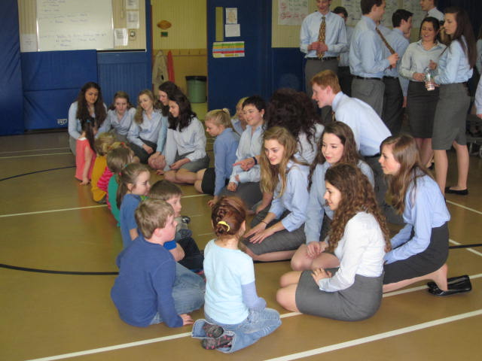
KMC Classroom Newsletter
Please visit our class website to find lots of pictures, audio clips and videos of your children. Also, please remember to read on Raz-kids.com daily to help your child build their fluency. Please also read to your child daily to show them modeled reading and also to build their love of reading. There will also be books going home on days when your child has guided reading. Please ensure that these books do not get lost or damaged because it takes a lot of time, effort and money for me to replace them. 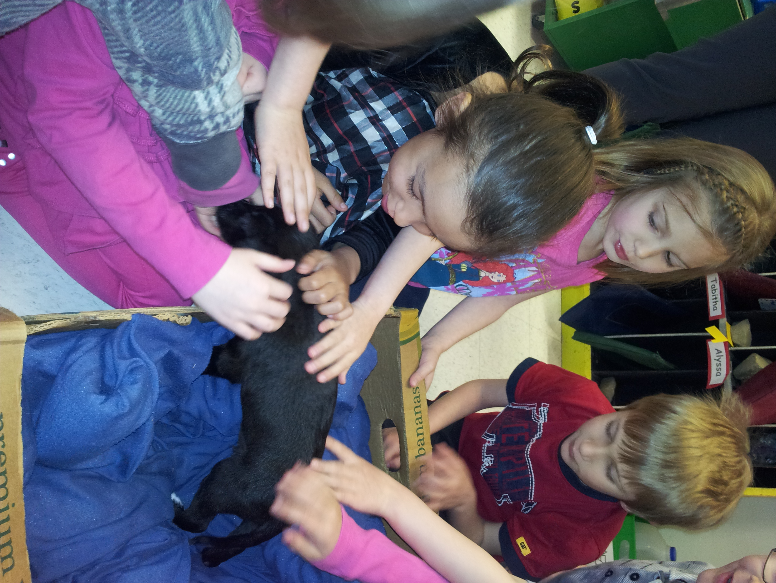
We had another special visitor this week. Miss Redmond’s new puppy Freya came to visit us. Sadly we have to say goodbye to Miss Redmond as she has to return to University next week. We will miss you Miss Redmond!

I will be sending home beginner level books for your child to practice. They should be able to read some of the sight words on their own and be able to figure out the rest of the sentence by reading the picture and looking at the initial letter of unknown words. Please read it to them first and then have them read it to you. As they read please have them point to each word as they read it. They will sometimes have sentence strips to put the story in order using the book or from memory if they can. It is also a good idea to ask them questions about the stories they read to you and the ones you read to them.

A newsletter also can extend classroom learning. Give students experience in writing for an audience by having them write articles describing class projects. Ask children to help you choose the colors of your newsletter, pick out clip art, put together story ideas, write and edit articles, and distribute the newsletter.

Reminders to Parents

Congratulations Students!
Special congratulations to the following students:
Madison Breau-Sherrard and Jada MacDonald for receiving Harkins Treasures for March and Claire Vickers and Craig Doyle for receiving Harkins Treasures for April!
Also, Congratulations to Alyssa, Craig, Michael, and Callie for having perfect attendance this month.


In Our Classroom

Literacy
This month we will continue to work on learning to read, spell and write stories. Students are reading emergent level books on their own and with assistant during Daily Five activities. They will continue to learn new sight words and practice building sentences. Students will also continue to learn words through rhyming and using word families.
Students will continue to work on writing during a daily Writers Workshop in which they see themselves as authors and their lives as stories to write about.
Math
Students are their unit on Geometry and Measurement. Also, they are enjoying building their mathematical skills primarily through the use of games. Please check our website for links to online games.

We had some very special visitors in April. The Windham Chamber Singers came to performed for us. They have performed such places as Carnegie Hall, the White house and now Harkins Elementary!

Harkins Elementary School
Miramichi, NB

Newsletter Date
May, 2013

Monday
Today we are learning about dinosaurs.
Tuesday
Today we are learning about pets.
Wednesday
Today we are learning about the solar system.
Thursday
Today we are going on a field trip to the zoo.
Friday
Today we have a special guest from the fire department to tell us about fire safety.

Ms. Stahl’s Classroom Newsletter Page 2

Upcoming Events
Classroom Open House
Tuesday, September 6, 7:30 P.M.
Ice Cream Social with the Faculty
Friday, September 9, 5 P.M.
School Assembly
This week's school assembly is on storybook characters. Children may dress up like a character on Thursday. (You might want to bring a change of clothes for the rest of the day.) Costumes can be as simple as a hat or a small picture of your character pinned to your shirt. Have fun.

Reminders to Students
- Bring money for field trip lunch
- Bring umbrella in case it rains
- Think of a costume for Friday’s assembly

Reminders to Parents

Congratulations Students!



This Week’s Assignments

This Week’s Highlights

